Competition Aerobatics
The popular characterization for this kind of flying is “stunt flying.” Pilots who engage in this activity are sometimes thought to be crazy daredevils. This romantic and somewhat sensational view is common in the media because it is exciting. It sells advertising and gets attention. The reality is very different.
The people competing at the Kathy Jaffe Challenge belong to the International Aerobatics Club (www.iac.org), an organization of pilots who work to improve their skills and perfect the accurate performance of aerobatics figures and routines to exacting standards. The contestants here will be graded by judges, much like the figure-skating contests popular in the Winter Olympic Games. The pilots flying here are sober, careful individuals who take pride in the attention they give to the safe flying and maintenance of their airplanes.
Aerobatics is a physically and mentally challenging sport that takes years to learn and a lifetime to master. World class pilots start with some natural talent, then dedicate thousands of hours in the air and more on the ground to train to be the very best.
As with the best baseball and football players, many desire the goal and few attain it. Unlike baseball and football players, the financial rewards are few. The primary reward is more like that of Olympic class athletes. It is the pleasure of having succeeded in creating a physical performance that is highly demanding, difficult, and sometimes beautiful to watch.

The Aerobatic Box
All of the competitors at IAC sponsored contests perform their aerobatics figures in a safe zone called the “Aerobatic Box.” The box keeps competitors in front of the judges.
The box lies over a one square-kilometer area on the ground delimited by white markers visible from the air. The markers show the corners, the center, and the center of each side. One kilometer is about 3,300ft.
The altitude for the bottom of the box varies for different levels of competition. The most advanced pilots may descend as low as 300ft above the ground. The beginning pilots must remain over 1,500ft above the ground.
There is a maximum altitude for all pilots of 3,500ft. This keeps the pilots low enough to be seen by the judges.

Pitch, Roll, and Yaw
Most airplanes, and all airplanes in aerobatic competitions, are controllable in three dimensions. The names of the three dimensions are “pitch,” “roll,” and “yaw.”
Pitch is motion of the airplane’s nose up and down. An airplane will generally climb as the nose (pitch) goes up and descend as the nose (pitch) goes down.
When an airplane rolls the wingtips move up and down.
Yaw is motion of the airplane’s nose and tail side-to side.
An airplane turns by coordinated use of pitch, roll, and yaw. An airplane that has rolled into a turn is sometimes described as being “in a bank,” or “banked,” as if following a banked, high speed curve in a road.
Point your web browser to the EAA Young Eagles Web site at http://www.youngeagles.org/games/pyr/ for an excellent interactive demonstration of pitch, roll, and yaw.
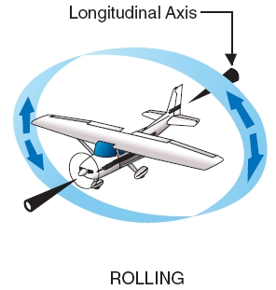
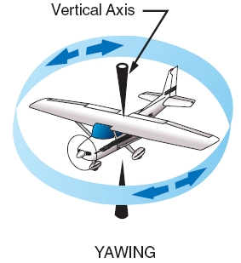
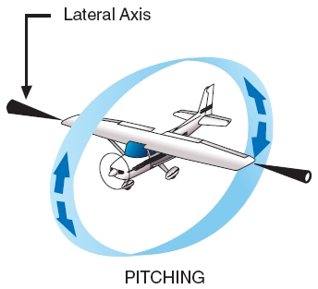

Aerobatic Sequences
An aerobatic sequence is a series of clearly defined aerobatic figures. Aerobatic figures are individual maneuvers such as loops and rolls that begin and end with horizontal, level flight (upright or inverted).
The system of diagramming aerobatic figures and sequences was developed by Jose L. Aresti in the early 1960’s. It shows what a pilot is expected to fly in a manner similar to the way music shows what a musician is expected to play.
The paragraphs that follow describe some of the notes, or aerobatic figures that appear in an aerobatic sequence. They show the Aresti symbol, give the name of the figure, and provide a short description of some of the things the judges look for in the figure.
The Slow Roll requires that the aircraft roll without changing its flight path. Judges will deduct points if the aircraft changes direction in the roll, pitches up, or down, or changes rate of roll during the maneuver.
Loop: The competitor must fly a perfect circle in the sky regardless of wind conditions. Judges will deduct for variations in the radius of the loop and for changes in roll or in heading.
Turn: The competition turn requires the pilot to roll on heading to a bank of at least sixty degrees, immediately begin a constant rate change of heading without climbing or descending, stop after 90, 180, 270, or 360 degrees, then roll on heading to level flight. Judges deduct for inadequate bank, changes in rate of turn, climbing or descending, and finishing off-heading.
Spin: The spin is a controlled maneuver in which the airplane essentially falls downward while rolling and yawing at the same time. Judges look for the nose and a wing to drop together, at the same time, in the entry to the spin. They look for a clean vertical down line after an exact number of quarter-rotations.
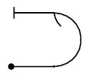The Immelman is a half-loop up followed immediately by a roll to upright. The half loop up must have constant radius. The roll must occur on a level line without delay after the half loop up.
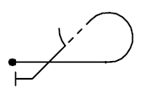The Half-Cuban requires a five-eighths loop of constant radius. The pilot must draw a forty-five degree line and center a roll to upright on that line. Judges deduct for changes in radius, steep or shallow lines, and rolls not centered on the line.
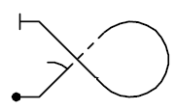Goldfish: The competitor flies two forty-five degree lines connected by a three-quarter loop. Any rolls must be centered on the lines. The loop must have a constant radius.
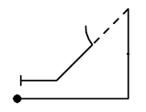The Wedge has a vertical line and a forty-five degree line. Judges deduct if the airplane is not vertical. If the airplane is slightly on its belly they call it “positive.” If it is slightly on its back they call it “negative.”
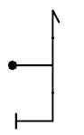In the United States we call this a “Hammerhead.” Elsewhere it’s described as a “Stall Turn.” The competitor flies straight up until the plane slows nearly to a stop, then turns the plane on the yaw-axis, with the rudder, and flies straight down. Judges deduct points if the plane rolls or pitches during the turn.
A Snap Roll is a very fast roll caused by rapid change in pitch and yaw, not by the ailerons as in a slow roll. Watch to see the nose move up abruptly just before the rotation begins.
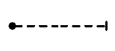Inverted flight: The Aresti symbol will show a dotted line whenever pilots must push the nose away from them to maintain the flight path.
A Rolling Turn will have one or more rolls integrated with the turn. The rolls may be inside, in the same direction of the turn; outside, in the opposite direction of the turn; or alternating inside and outside. The rate of turn and the rate of roll must be constant. Both the turn and the rolls must end at the same time after 90, 180, 270, or 360 degrees of heading change.
Point roll: Rolls may contain hesitations, or “points.” A two indicates hesitations every half roll. A four every quarter roll, and an eight every eighth roll. The pilot must pause the same amount of time at each point and move between points with a constant roll rate. The points should look like the ticking of a clock.
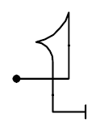In a Tail Slide the airplane will briefly fly backward. The competitor flies a vertical line up until gravity begins to pull the airplane back down tail-first. The pilot must cause the plane to flip nose to tail wheels-down (positive) or wheels-up (negative) after sliding at least one-half the length of the fuselage. The pilot must fly a vertical line down before resuming level flight.
A Negative Snap Roll is much like the positive snap roll described earlier, only watch for the nose to move downward (toward the wheels) rather than upward. The nose will move abruptly before the onset of a very rapid roll.

Competition Categories
Powered airplane competitions of the International Aerobatic Club have five categories, or levels of competition of increasing level of difficulty. The five categories are Primary, Sportsman, Intermediate, Advanced, and Unlimited.

Primary
The Primary category is the most basic, entry level category of aerobatic competition. Pilots must demonstrate a spin, loop, roll, and competition turns.

Sportsman
The Sportsman category offers a greater challenge to the beginning competitor. It includes a greater number and variety of figures, including the hammerhead.
Additionally, Sportsman competitors may design a “free” sequence. A free sequence is a sequence of the competitor’s design that satisfies constraints on the type of figures flown, the number of figures, and the total amount of difficulty of the sequence.

Intermediate
The Intermediate category adds the snap roll, some inverted figures, and the rolling turn. Intermediate competitors must provide a free program. If there is time at the contest they may also be required to fly an “unknown” compulsory sequence.
The Contest Director provides the unknown sequence to the competitors at least 12 hours before the competitors must fly it. Competitors may have practiced many of the figures in the unknown, but have no opportunity to practice the sequence before performing it for the judges at the contest.
You may see competitors doing a strange dance next to their airplanes as they rehearse the sequence on the ground before their flight.

Advanced
The Advanced category includes more challenging figures with multiple rolls and snaps on each figure and more inverted figures.
Advanced pilots fly a known compulsory, free, and unknown compulsory sequence.

Unlimited
The Unlimited category is the most difficult of all. Only the most capable pilots flying the most capable airplanes can manage the figures required in the Unlimited category.
Pilots flying Unlimited are flying better than air-show performers, on a level with the best world competitors.

